10352 S. Western Ave.
Chicago, IL 60643
(773) 980-1100
info@thequilterstrunk.com
www.thequilterstrunk.com

Easy Charm Square Pillow
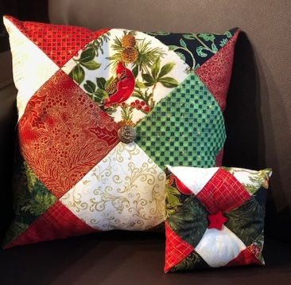
Fabric & Notion Requirements:
- 16 squares of fabric that are 5” x 5” each or use 16 squares from a charm pack. You can use as few as two different colors/prints or as many as 16. This will make a pillow that is approximately 12” square. You can also use smaller or larger squares to make different sized pillows.
- Poly-fil stuffing
- Buttons (optional)
Assembly:
- Arrange your 5” squares into a grid that is 4 squares tall by 4 squares wide.

- Using a 1/4” seam allowance, sew 4 squares into a rows and press. Repeat with remaining squares to create 4 rows. Sew the 4 rows together, matching seams, to form a larger square.

- Next, fold the square in half with right sides together, and sew the two short ends with a 1/4” seam allowance from the fold to the long open edge.

- Holding the open edges slightly apart, rotate the seams that you just sewed so that they come together in the middle of the pillow cover. One diagonal edge of the pillow cover will still be unsewn.

- Sew that seam, leaving about 4-5” open in the seam for stuffing.

- Turn the pillow cover right side out, press, and insert poly-fil stuffing.

- Use a threaded hand sewing needle to stitch the opening closed, using a ladder stitch. Optional: add a button to the center of either or both sides for decoration.
@ Copyright 2023, The Quilter’s Trunk, LLC. Pattern may not be copied or sold without permission from The Quilter’s Trunk, LLC.

